Bryan Cabrera

4/13/2024

Module 4.2 Assignment

**Initial Connection:** 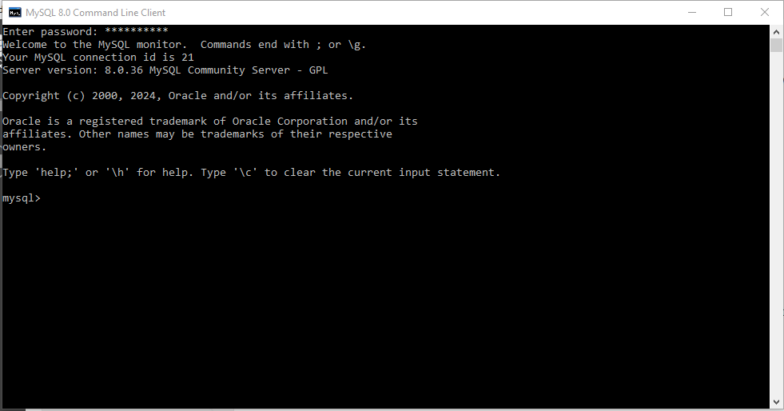

**SQL Command:** 